NWRacing Data Analysis
& Ratings Service

New customers to NWRacing may get a ‘drowning in stats’ feeling on first view of the daily spreadsheet! However it really is easy to understand once you’re up and running and you will soon get an understanding of the layout. It will take a few days of navigation before you are up to speed, but the data available to you will certainly help any bettor with their own decision & selection process.
All UK & Ireland meetings are covered. These meetings are selected by our software that analyses each race to find the best statistical data on any given day.

Main Ratings Spreadsheet.

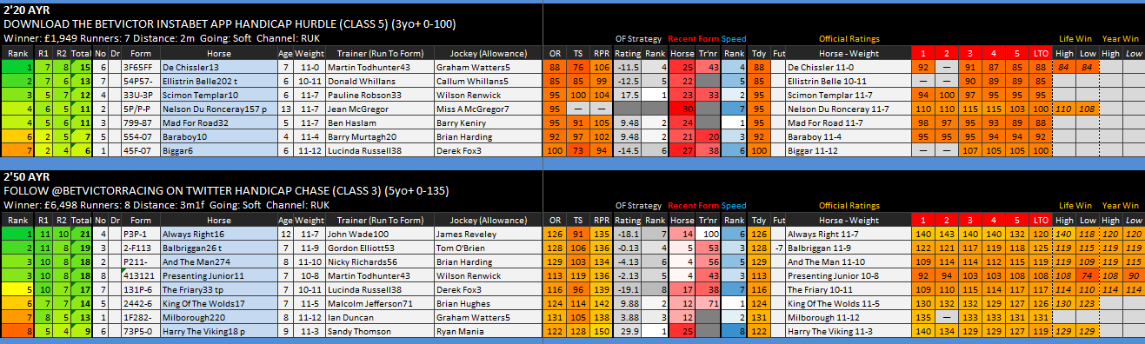
From the example above we will be working from ‘Left to Right’ with our explanations.

Across the top black bar you will see details of the time of race and course details. You will also have details of the name of the race, alongside the grade of race and age range horse details. Winners prize money is given, the amount of runners, as well as distance of the race, ‘Going’ details and details and what channel you can watch the race can also be seen.

Working from Left to Right….
The first four columns you will come across are our unique ratings & rank.
The R1 & R2 columns are our two sets of ratings. The ‘Total’ column is the overall rating. The ‘rank’ column puts each horse in ratings order.

We then move on to the horse data. The next column is the horses’ saddle cloth number.
We then have the stall bias of each horse. On occasions these details will be highlighted in green, yellow & red. If highlighted in green this will mean there is a strong draw bias in favour of that horse. If highlighted in yellow this means the horse has an above average draw bias. If highlighted in red this means there is a strong negative bias. If not highlighted the horse has no particular positive or negative draw bias.

The next column gives us details of each horse’s previous runs. The details are easy to follow with 1 meaning a horse finished first, 2 stands for second etc. Any horse that has a zero has finished tenth or worse in that race. The latest form figures are to the right. As you can see from the example below ‘Presenting Junior’ won last time out, as did ‘Always Right’. Three runs ago ‘Milborough’ came second.

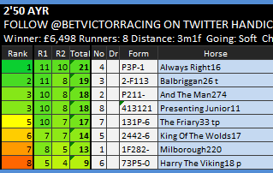
Other abbreviations you may find in the form column are …..
F = Fell.
B = Brought Down.
P = Pulled Up.
S = Slipped/Fell.
R = Refused.
U = Unseated Rider.

The next column gives you the name of each horse. The numbers after each horses name are the days since the horse last ran. You can see from the sample above that ‘Always Right’ last ran 16 days ago, ‘Milborough’ ran 220 days ago. Any letters after a number are an abbreviation of any ‘aids’ a horse maybe wearing. For example ‘Balbriggan’ has a ‘t’ which stands for tongue tie.
Other abbreviations include …
e/s = Eye Shield.
v = Visor

The next columns will show you the age of the horse, then you have the weight in ‘stones & pounds’. This is the total weight that the horse will be carrying that day.
Continuing to move from left to right on the spreadsheet we then come to the trainer and jockey details.
Trainer (RTF) simply gives you the name of the trainer of each horse. The ‘RTF’ figure stands for ‘Racing Post Trainer Form’. This is a percentage given by the Racing Post on how successful each trainer has performed in the past 14 days. The higher the figure the better they have performed. For example ‘John Wade’ has a figure of 100, this means the trade has been successful with all his runners in the past 14 days.
Jockey (Allowance) gives you the name of each jockey. Any number after a jockeys name signifies the amount of weight taken off the horse. This is allowed because inexperienced jockeys which are known as ‘apprentices’ are allowed to take weight off a horse’s back. From the example above you can see Derek Fox is allowed to take 3lb off the horse, Graham Watters is allowed to take 5lb off the horses weight. When a jockey rides a certain amount of winners their ‘claim’ is reduced. You can see that most jockeys have ‘ridden out their claim’ which means they are not able to take any weight off a horse’s back.

Official Figures
Continuing to work from left to right on the daily spreadsheet we then come to the Official Figures.

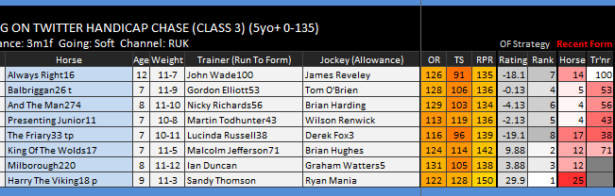

These figures are …….
OR = Official Rating.
TS = Top Speed.
RPR = Racing Post Rating.

These figures given are each horses latest figures for that particular category. These are colour coded on your spreadsheet, with the brighter the colour the better the figure. The better the figures the better chance a horse should have of winning that race.
The next two columns are data from our ‘Official Figures’ strategy. The rating is a figure that our software has given us using the official figures available to us. As you can see ‘Harry The Viking’ has a figure of 29.9 meaning it is the best rank in the race. Second is ‘King Of The Wolds with a figure of 9.88.
The following column is once again concentrating on the Trainer ‘Run To Form’ data mentioned earlier in the e-book.

Horse Speed Figures.
The next column gives a ranking to each horse from our speed figures data.
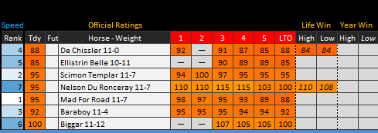
From the example above you can see that ‘Mad For Road’ has the best speed figure as its ranked top. Second best is ‘Scimon Templar’. Many bettors prefer to use Speed Figures as their main analysis, this is a very good tool.
Official Figures
These figures give you the data of each horse’s past six runs.
‘Biggar’ last ran (LTO) off a figure of 100, the time before that it ran off a figure of 105. This means this horse has dropped 5lb in weight since its last run. The ‘Tdy’ column shows you the official figure it runs off today, that figure is 100 once more.
Horses that are dropping in the weights such as ‘Nelson Du Ronceray’ (dropped 20lb in past three runs) could be ready to win, especially if their form figures have been decent of late.
The ‘life’ & ‘year’ data gives you the highest & lowest figures the horse has won off in its life and in past year.

Trends.
The ‘Trends’ section of the daily spreadsheet concerns past trends data of that particular race from previous years.
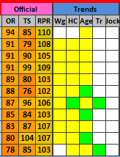

The different categories are…
Wg = Weight.
HC = Handicap Rating.
Age.
Tr = Trainer.
Jock = Jockey.

Any box highlighted in green has a high positive trend.
Any box highlighted in yellow has good trend statistics.
Any box not highlighted has no preference.

For example –
A green highlighted box for the Trainer sections indicates that the trainer has done well in this race in past years.
A green highlighted box in Handicap Ratings indicates that the horse’s current handicap mark has performed well with other horses in previous races in past years.

Course Statistics
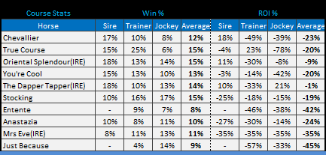
This set of information gives you the Sire, Trainer & Jockey stats for the course.
For example – You can see that the ‘Sire’ of True Course had a 15% win strike rate at the course. The trainer has a 25% win strike rate with his/her horses at the course. And today’s jockey has a 6% win strike rate at the course. This gives a total average of 15%.
The ROI data shows the profit/loss to a percentage.

Analysis
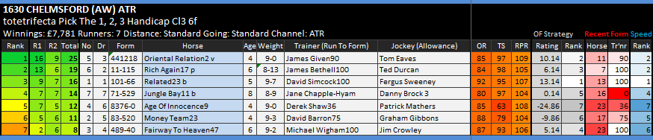
So how do you use the data analysis available?
This is of course up to the individual and what they are looking for. My personal tastes are to find value selections from horses that come out well on a number of angles.
In the above race we can see that Oriental Relation is well clear of the rest of the field as far as ratings are concerned (Top of both ratings). Past form figures have been good (apart from last run) and the trainers has a RTF of 90% with its latest runners. Our OF Strategy has the horse ranked 2nd, and the Speed Rank is also 2nd. So over all the horse looks like it could go well.
Looking at the results of the race.
Our Top Rated horse Oriental Relation Won at Betfair odds of 3’94 which was good value.

Mini Spreadsheet Strategy Selections.

This part of the spreadsheet gives you information on a number of strategies that the management of NWRacing regularly use.
We also confirm our ‘highlighted’ selections on this page.

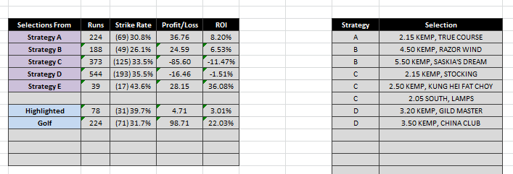

As well as giving you the strategy selections each day, we also regularly update each of the strategy results. This means you can keep up to date with what strategy is performing the best.

NWRacing is an established service that has stood the test of time. Many services have come and gone in the past twenty years but we are still going strong.
This is because we are professional and pride ourselves on good customer service.
We are always here to help and answer any questions or queries you may have.
NWRacing offers stats based daily spreadsheet, which is to be used for the purpose of finding investments. How it’s used is up to each individual.
We also offer our own recommendations with our highlighted horses and mini strategy selections. Simply following these advices each year will make you a significant profit.

We would like to thank you for your interest in our service.

If you have any questions please use the contact details below.

Email – Neil Stevens-Wood (Manager) n.stevenswood@gmail.com

Other Contact - http://www.nwracing.co.uk/contact-us.php

Office - 01384 351334 (9am – 12pm, Monday – Friday).

Please note – N.W.Racing issue their daily spreadsheet six days a week (Monday-Saturday). However on many occasions they also work Sundays. Please be aware of this when becoming a member.
Our ‘Terms & Conditions’ are available to view on our website.

